1. 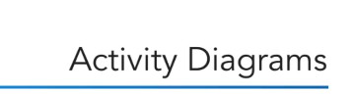 
2. Activities diagrams can be used to describe workflows.
3. The actions are represented by nodes.
4. 
5. 
6. 
7. 
8. 
9. 
10. 
11. 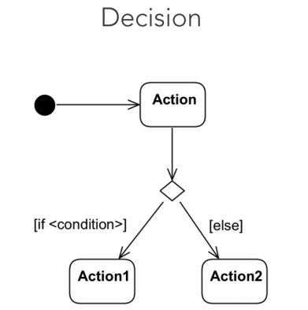
12. 



1. 
2. 
3. 
4. 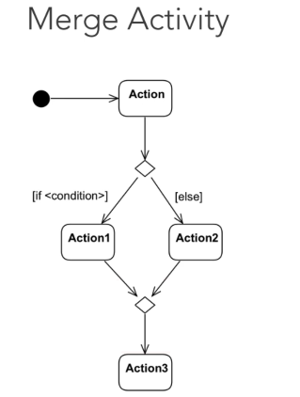
5. 
6.    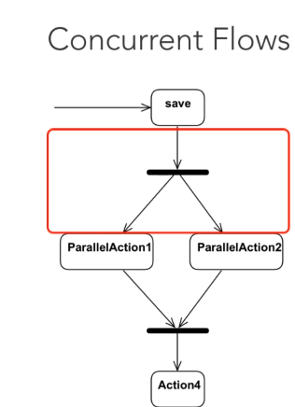
7. 
8. 
9. 
10.  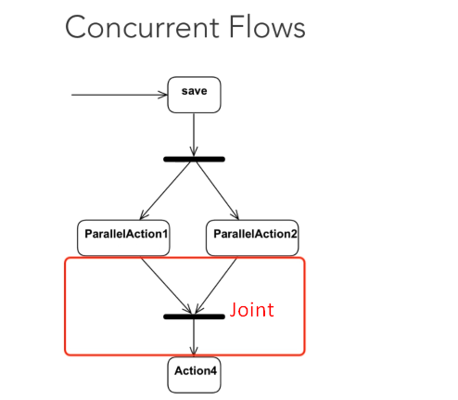
11. 
12. 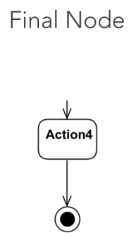
13. 
14. 